

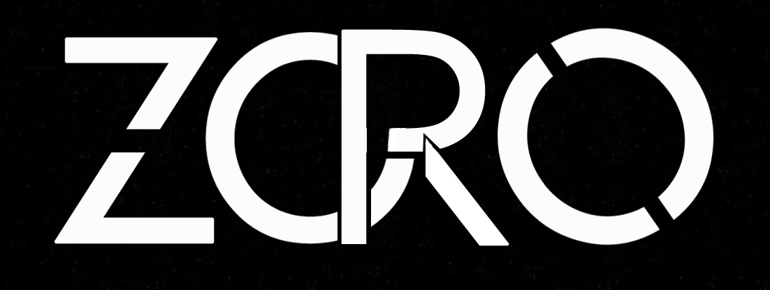

**SYNOPSIS OF THE PROJECT**

Astitva Srivastava

Anuj Mishra

[B.Tech CSE - 4th Year]

[Section - A]

**INTRODUCTION TO ZORO**

**Project Overview :**

The purpose of this project is to provide a platform for users and rental product(s) owners in an effective and efficient manner. ZORO is a one stop rental portal.

Users can provide things like clothes,shoes, books, vehicles, electronics, etc. on rent and those who in need of such things can easily approach the owners through our online portal.

Main objective of ZORO is to digitalize the interaction between renters and customers. The whole process of getting items on rent is going to be just a matter of few clicks.

**Project Description :**

This web application would be implementable irrespective of the location. Instead of providing products from only one rental show room the application is acting as interface between different users (borrowers and lenders). There is no restriction of rental showrooms or owners for our website. Means any owner want to display their products on our site then they simply register in our site by providing personal information and product description(s).This web application is providing some additional features for vendors to edit or delete their products. Customers need to register with our site as they search and place orders on our site. We are responsible for communication between customer and the vendor and maintain the database. It also providing an extra module that it accepts feedback from the Customers.

There are many rental systems are available in online. But, they are not providing all products at one place. Also many of them restricted to only one city. That means car rental system in online deals only with cars. Also many of them are not providing effective communication between customer and the vendor. Also present rental systems restricted to only one vendor means products are supplied only from one rental show room.

**Functionalities of ZORO :**

* Provides the searching facilities based on various factors. Such as Customer, Category, Sales, Payment
* ZORO also manage the Shipping details online for rental details, payment details.
* It tracks all the information of Products, Shipping, Sales etc.
* Manages the information of Products
* Shows the information and description of the Customer to increase efficiency of managing the Customer, Products
* It deals with monitoring the information and transactions of rentals.
* Manage the information of Customer.

**Other Features** :

* Provides search results according to rating and popularity.
* Feedback option for customers.
* Secured communication between owner and customers.
* Aadhar - UID and Phone number verification to avoid frauds.
* Universality in product’s category.
* Shipping facilities.

**MODULES**

The system after careful analysis has been identified to be presented with the following

modules:

**Registration (User/Vendor) -** The Vendor/User fills the registration form by giving the personal information and successfully registers with the website.

**Product (Description/Images/Status) -** After entering into vendor's homepage vendor will add his products by filling add product form, by providing sufficient details about product such as product id, available dates, rent etc and upload the image of that product.

It consists of following sub modules:

**1. Update Product:** Vendor can update the existing product details such as rent, available dates, etc. by entering the product id of that product.

**2. Delete Product:** Vendor can delete his products by entering the product id.

**Data base maintenance -** The data provided by the Vendors such as product details, personal details, etc. and data provided by the customer such as feedback and booking details will be maintained in a data base by the website administrator.

**Searching and booking the product -** The Customer after accessing the site searches for products, if he/she finds the required product then he/she need to fill the booking form and submit to the database.

**Authentication -** Authentication is nothing but providing security to the system.

Here everyone must enter into the system through login page. The login page

will restrict the unauthorized users. A user must provide his credential like user

Id and password for log into the system. For that the system maintains data for

all users.Whenever a user enters his user id and password, it checks in the database for user existence. If the user exists he can be treated as a valid user. Otherwise the request will throw back.

**SOFTWARE QUALITY ASSURANCE (SQA) STRATEGY**

* In the first step, we will select the test factors and rank them. The selected test factors such as reliability, maintainability, portability or etc. , will be placed in the matrix according to their ranks.
* The second step is for identifying the phases of the development process. The phase should be recorded in the matrix.
* The third step is that identifying the business risks of the software deliverables. The risks will be ranked into three ranks such as high, medium and low.

**SOFTWARE REQUIREMENT SPECIFICATION**

**(SRS)**

The Software Requirements Specification is produced at the culmination of the analysis task. The function and performance allocated to software as part of system

engineering are refined by establishing a complete information description, a detailed functional and behavioural description, an indication of performance requirements and design constraints, appropriate validation criteria, and other data pertinent to requirements.

We identified the following requirements for our system :

* System needs store information about new entry of Customer.
* System needs to help to keep information of Products and find the results as per various queries.
* System need to maintain quantity record.
* System need to keep the record of Category.
* System need to update and delete the record.
* System also needs a search area.
* It also needs a security system to prevent data.

**FEASIBILITY STUDY**

**Economical Feasibility :**

This is a very important aspect to be considered while developing a project. We decided the technology based on minimum possible cost factor.

* All hardware and software cost has to be borne by organization.
* Overall we have estimated that the benefits the organization is going to receive from the proposed system will surely overcome the initial costs and the later on running cost for system.

**Technical Feasibility :**

This included the study of function, performance and constraints that may affect

the ability to achieve an acceptable system. For this feasibility study, we studied

complete functionality to be provided in the system, as described in the System

Requirement Specification (SRS), and checked if everything was possible using

different type of front-end and back-end platforms.

**Operational Feasibility :**

No doubt the proposed system is fully GUI based that is very user friendly and all

inputs to be taken all self-explanatory even to a layman. Besides, a proper training has been conducted to let know the essence of the system to the users so that they feel comfortable with new system. As far our study is concerned the clients are comfortable and happy as the system has cut down their loads and doing.

**SYSTEM DESIGN**

**1. Primary Phase :**

In this phase, the system is designed at block level. The blocks are created on the basis of analysis done in the problem identification phase. Different blocks are created for different functions emphasis is put on minimising the information flow between blocks. Thus, all activities which require more interaction are kept in one block.

**2. Secondary Phase :**

In the secondary phase the detailed design of every block is performed.

The general tasks involved in the design process ate the following :

* Design various blocks for overall system processes.
* Design smaller, compact and workable modules in each block.
* Design various database structures.
* Specify details of programs to achieve desired functionality.
* Design the form of inputs, and outputs of the system.
* Perform documentation of the design.
* System reviews.

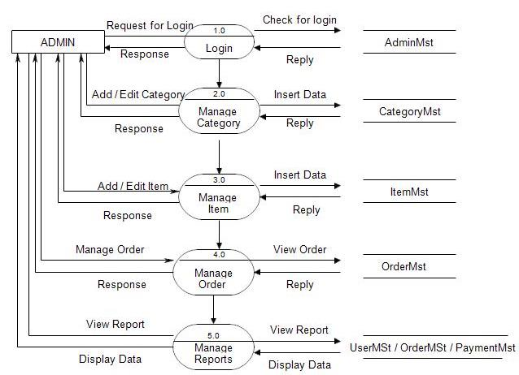

**PRELIMINARY PROJECT DESCRIPTION**

The first step in the system development life cycle is the preliminary investigation to determine the feasibility of the system. The purpose of the preliminary investigation is to evaluate project requests. It is not a design study nor does it include the collection of details to describe the business system in all respect. Rather, it is the collecting of information that helps committee members to evaluate the merits of the project request and make an informed judgement about the feasibility of the proposed project.

**Running Cost :**

Besides, the initial cost the long term cost will include the running cost for the

system including the AMC, stationary charges, cost for human cost for update/renewal of various related software.

**Need for Training :**

The users along with the administrator need to be trained at the time of implementation of the system for smooth running of the system. The client will provide the training site.

We talked to the management people who were managing a the financial issues

of the such systems,, the staff who were keeping the records in lots of registers and the reporting manager regarding their existing system, their requirements and their

expectations from the new proposed system. Then, we did the system study of the

entire system based on their requirements and the additional features they wanted to incorporate in this system. Reliable, accurate and secure data was also considered to be a complex task without this proposed system.

The new system proposed developed by us will ease the task of the organization in consideration. It will be helpful in generating the required reports by the staff, which will help them to track their progress and services. Thus, it will ease the task of management to a great extent as all the major activities to be performed, are computerized through this system.

**IMPLEMENTATION METHODOLOGY**

ZORO is based on Model View Controller or MVC as it is popularly called, a software design pattern for developing web applications.

A Model View Controller pattern is made up of the following three parts:

**Model -** The lowest level of the pattern which is responsible for maintaining data.

**View -** This is responsible for displaying all or a portion of the data to the user.

**Controller -** Software Code that controls the interactions between the Model and View.

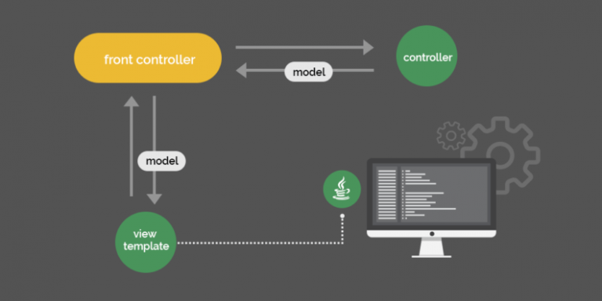

**Front End** :

Front end of our portal is developed on **HTML 5**, designed using **CSS Less** and main functionality is given through **AngularJS.**

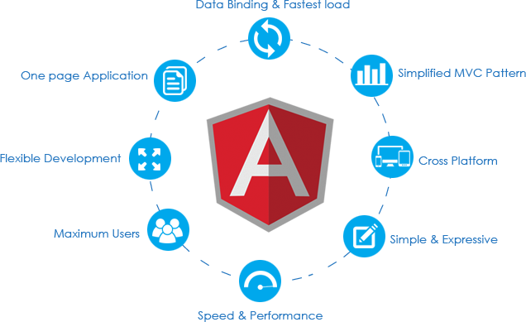

**Back End** :

Back end of our portal is managed using **Java EE**, with **Spring Framework.**

The database is maintained using **MySql.** All the transactions are done securely with the help of **Hibernate ORM.**







**Communication Between Client & Server :**

Our system communicates between different modules using **REST Web Services.** We have implemented modern Spring’s security features in order to ensure the communication security.

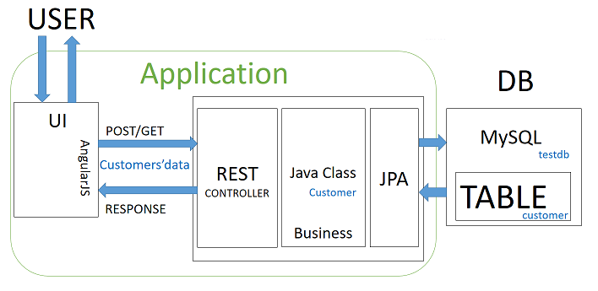

|  |  |
| --- | --- |
| NAME OF COMPONENT | SPECIFICATION |
| Operating System | Windows, Mac OS, Linux, Unix (any) |
| Browser | Google Chrome, Mozilla Firefox, IE (any) |
| Web Server | Tomcat 9 |
| Programming Language | Java |
| Scripting Language | Java Script |
| Database | MySql |
| Frameworks | SPRING MVC, RESTful Web Services |
| Database Connector | MySQL JConnector & Hibernate ORM |

**SYSTEM ANALYSIS**

The aim of proposed system is to develop a system of improved facilities. The

proposed system can overcome all the limitations of the existing system.

* The system provides proper security and reduces the manual work.
* Ensure data accuracy's.
* Proper control of the higher officials.
* Minimize manual data entry.
* Minimum time needed for the various processing.
* Greater efficiency.
* Better service.
* User friendliness and interactive.
* Minimum time required.

**ADVANTAGES OF ZORO**

üCollaborating suppliers and needy ones.

üProviding a variety of options to choose from.

üPromoting flexible lifestyle by keeping you into the trend.

üCreating employment opportunities.

üReducing pollution and fuel crisis, thereby helping environment.

üCan help lesser known lenders to expand their business.

üCan reduce product’s cost, thereby causing a decline in inflammation

and improving economical conditions.

**LIMITATIONS OF ZORO**

ü Needs in-depth knowledge of changing market demands.

ü Developing trust of customers will be difficult initially.

ü Project will require complex and expensive advertisement strategies during its initial stage.

**FUTURE SCOPE OF ZORO**

Apart from improving and digitalizing renting process, we are thinking of adding following extra features in future :

**Sharing :** People can share rides, movie tickets or other goods.

**Intra - Delivery :** We will provide low cost delivery with in a city, area or zone.

**Group Shopping :** People can contribute money to buy a expensive amenity and then share with each other later.

Above mentioned features are still under research.

**ZORO** has the capability to introduce the element of flexibility in the lifestyle of people, to make the way of living easier and comfortable by providing a quicker way of sharing products and services, and at the same time can contribute towards socio-economic growth.

With necessary contribution and co-operation, **ZORO** can change the face of modern economy.